PYTHON WEB DEVELOPMENT – TUTORIALS
CHAPTER 4: PYTHON NATIVE DATATYPES
TOPICS COVERED
Apart from regular data types, python has some new native data types. There are,
4.1 LIST
4.2 TUPLE
4.3 SET
4.4 DICTIONARIES
4.1 LIST
Salient features of list are,
- List contains ordered collection of data items.
- List values are indexed.
- List values enclosed in brackets – [ ]
- List values are mutable and changeable.
- List allows duplicate values to be present inside it.
- List also allows insertion preservation order.
- List also appends new data item with old data items.
- List supports heterogeneous objects.
- Popping of elements can be removed from right to left.
- Manually created using list() constructor
- List comprehension could be done with the help of following constructors and methods.
  - Iter()
  - __next__()
4.1.1 BUILT IN FUNCTION SUPPORT FOR LIST
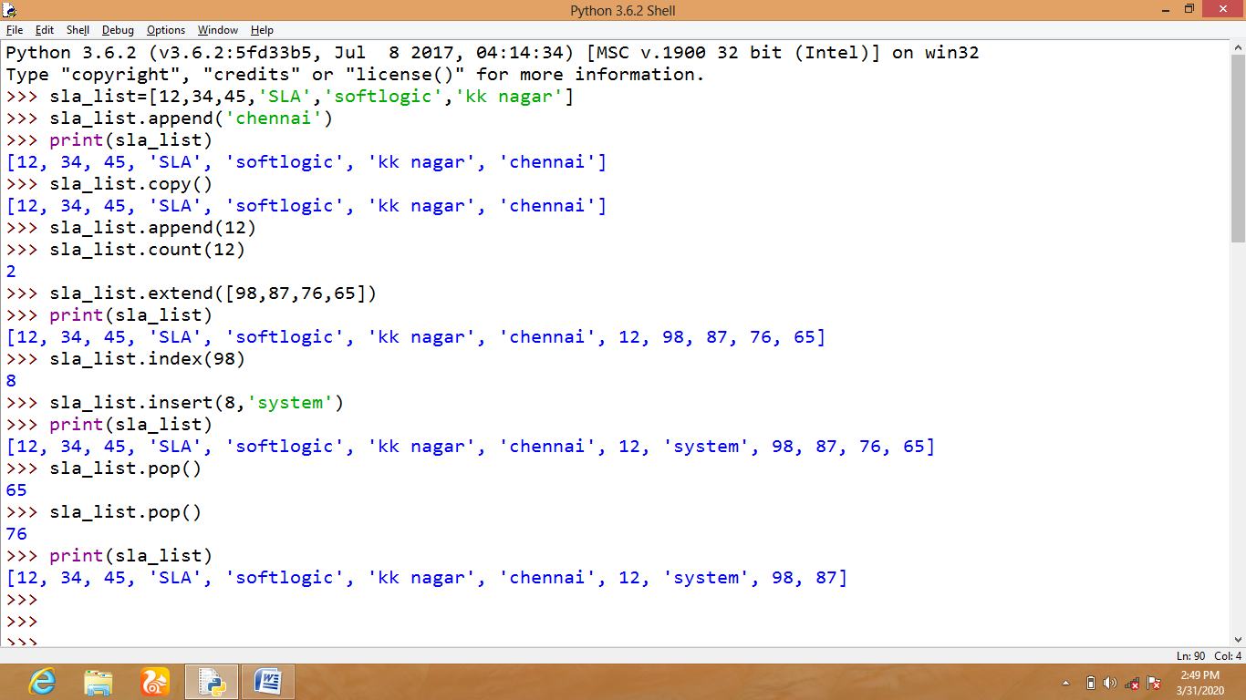
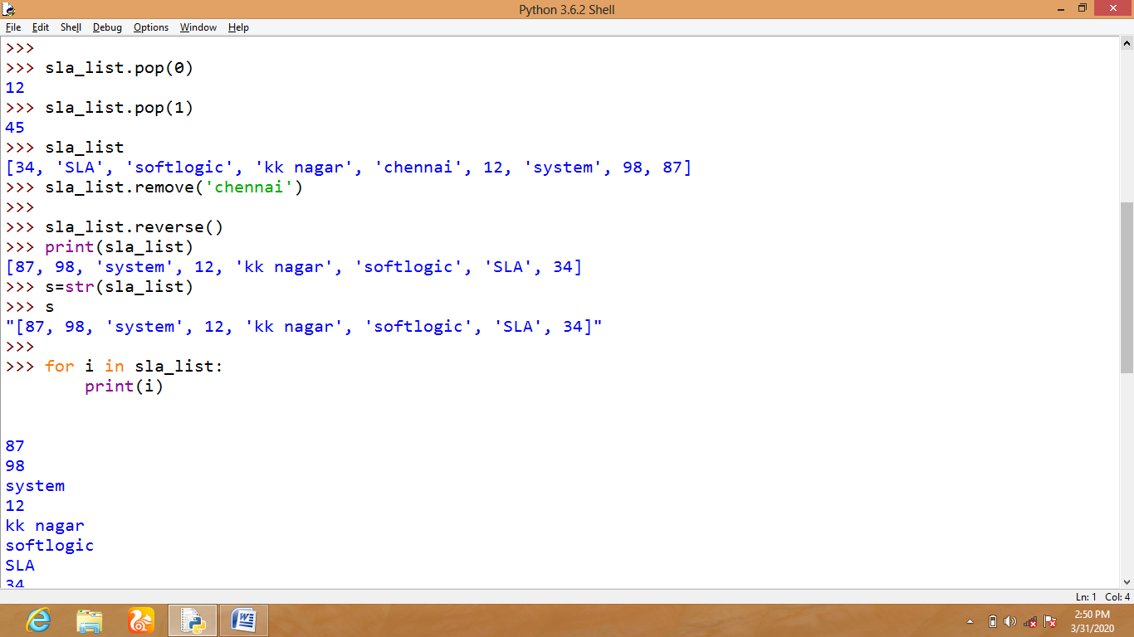
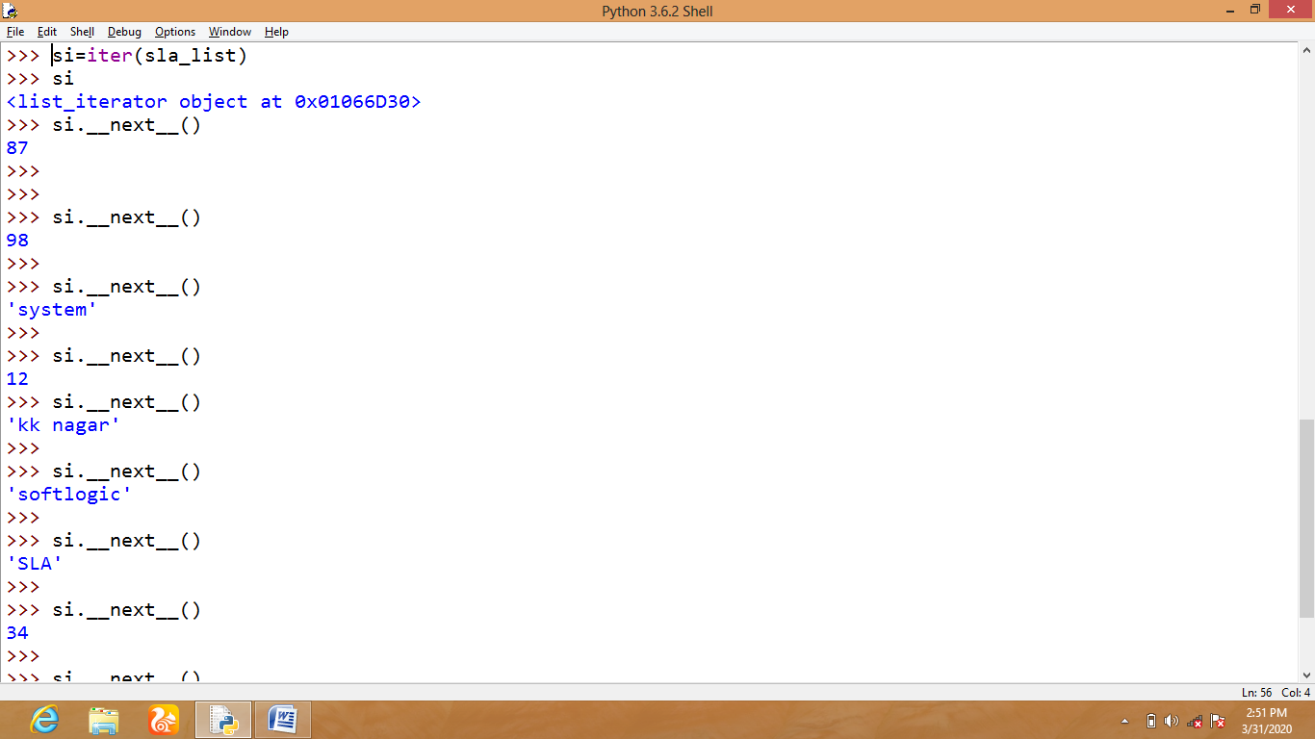

4.2 Tuples
Salient features of Tuples are,
- Tuples contains ordered collection of data items.
- Tuples values are indexed.
- Tuples values enclosed in parenthesis – ( )
- Tuples values are immutable and unchangeable.
- Tuples allows duplicate values to be present inside it.
- Tuples also allows insertion preservation order by using concatenation and repetition.
- Tuples also appends new data item with old data items.
- Tuples supports heterogeneous objects.
- No Popping of elements in set.
- Manually created using tuple() constructor
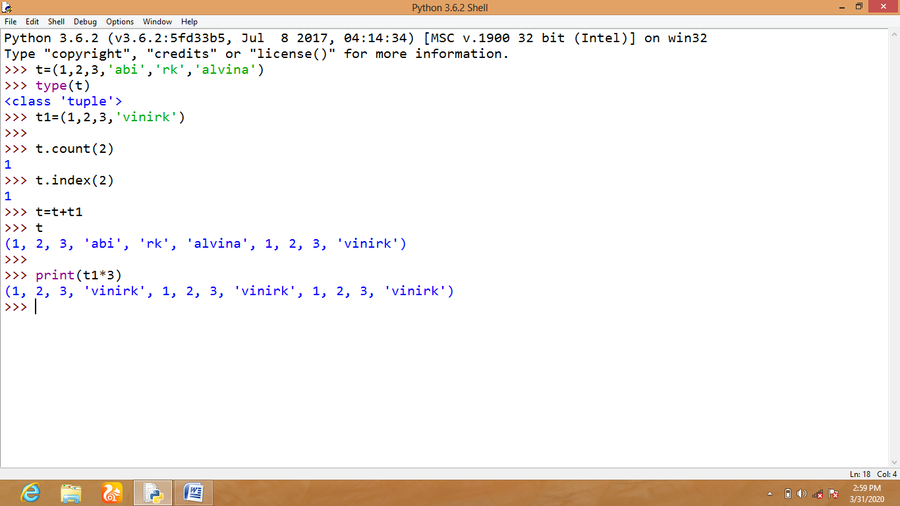
4.3 SET
Salient features of set are,
- Set contains unordered collection of data items.
- Set values are unindexed.
- Set values enclosed in braces with only values inside it –{ }
- Set values are mutable and changeable.
- Set does not allow duplicate values.
- Set partially follows insertion preservation order because of internal sorting of elements.
- Set supports heterogeneous objects.
- Popping of elements can be removed from left to right.
- Manually created using set () constructor.
- Set supports set theory operations like,
  - Intersection
  - Intersection_update
  - Difference
  - Difference_update
  - Symmetric_difference
  - Symmetric_difference_update
  - Discard
  - Pop
  - Union
  - Update
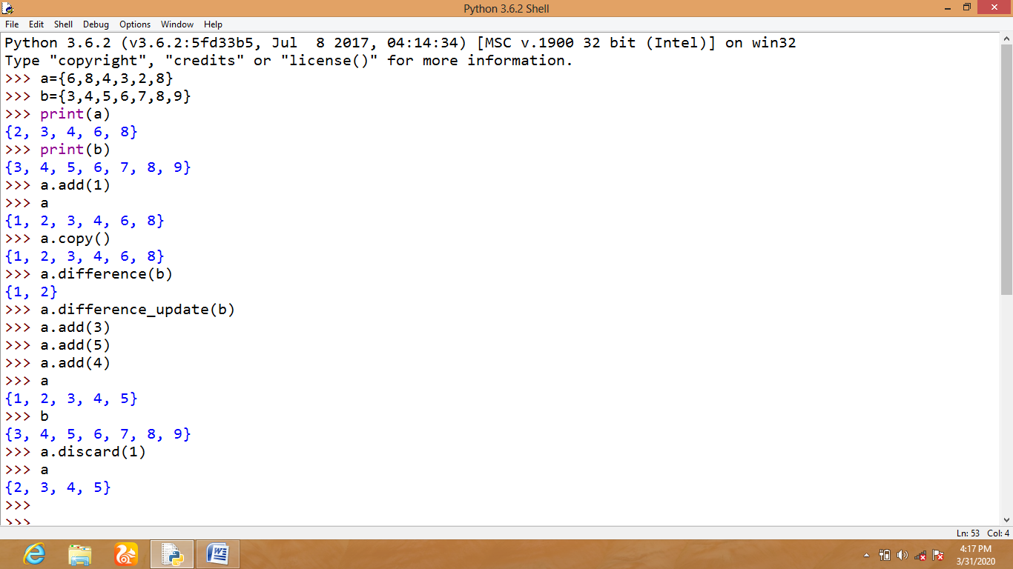

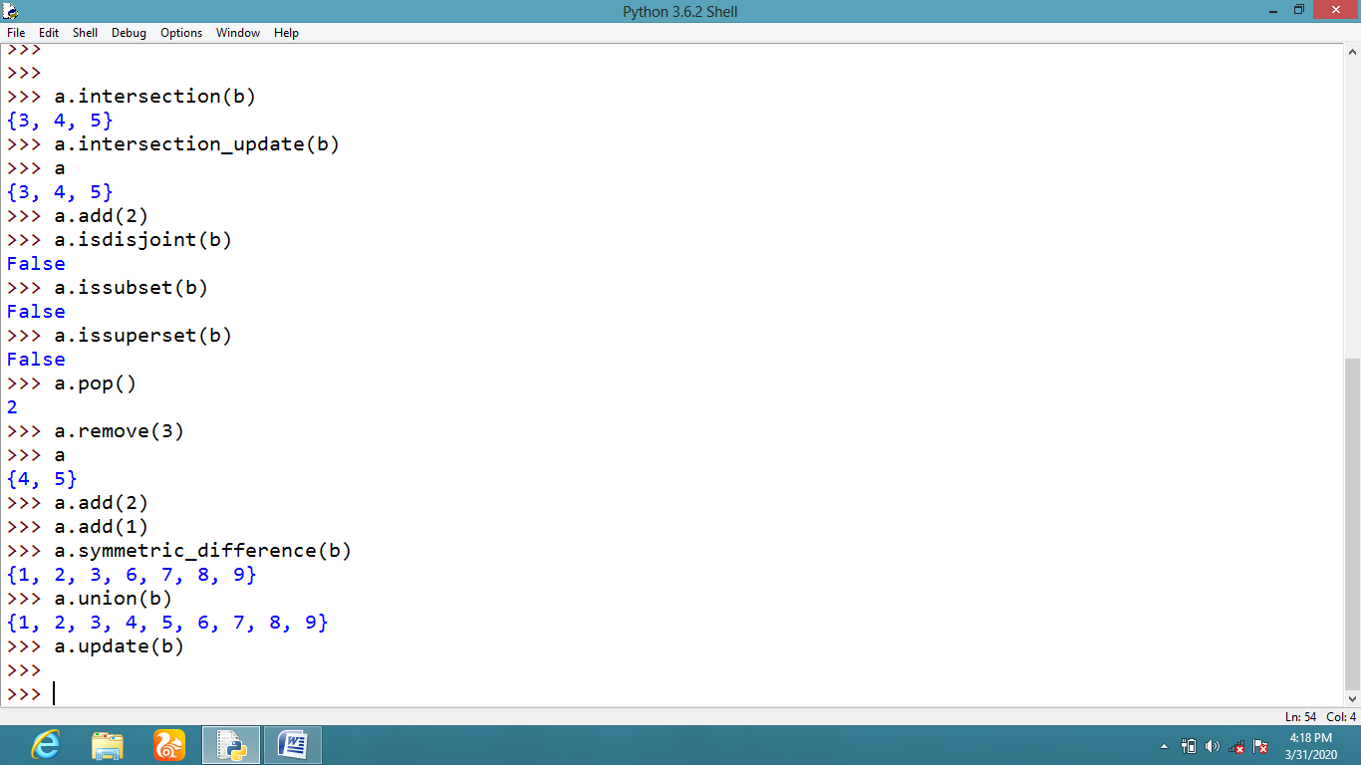
4.4 DICTIONARIES
Salient features of Dictionaries are,
- Dictionaries contain unordered collection of data items.
- Dictionaries value is indexed.
- Dictionaries value is enclosed with in braces with key & values inside it as a pair –{K:V }
- Dictionaries value is mutable and changeable.
- Dictionaries do not allow duplicate values.
- Dictionaries partially follows insertion preservation order because of internal sorting of elements.
- Dictionaries support heterogeneous objects.
- Popping of elements can be removed from left to right.
- Manually created using dict () constructor.
- Dictionaries allow the following actions,
  - Fromkeys
  - Clear
  - Copy
  - Get
  - Items
  - Pop
  - Popitem
  - Set default
  - Update & values
